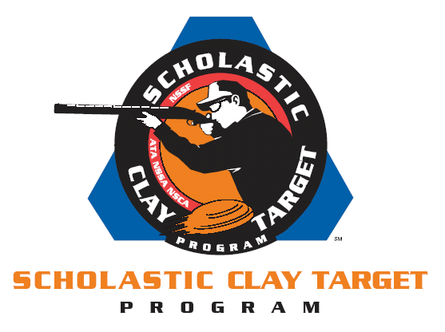

9th Annual
Kansas State University/SCTP
Shootout at the Crossroads
March 8-9, 2014

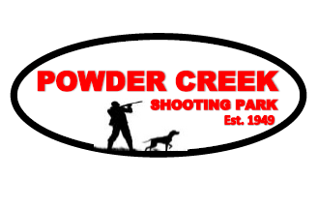

Powder Creek Shooting Park
8601 Monticello Rd. Lenexa KS 66227

6:30 am registration – 8:00 am start time
7:15 am – Mandatory Coaches/Shooter Meeting

400 Target Program
100 American Trap 100 Wobble Trap
100 American Skeet 100 Sporting Clays

Shoot entry $150 per shooter
- 400 targets American Trap, American Skeet, Doubles Trap, & Sporting Clays
- 5 person teams
- Men’s, Women’s, & Team awards
- 195 shooter maximum

Single Event Prices
- $45 Sporting Clays
- $32 American Trap
- $32 Wobble Trap
- Due to limitations skeet is only available to those shooting the entire program.
- Make-A-Break available sponsored by Pheasants Forever/Quail Unlimited Scholarship
- Breakfast & Lunch will be available
Event Entry
Online entry available through www.winscoreonline.com online entries must be received before March 6, 2014. Teams are based on the HOA and must squad together for the entire competition. See second page for instructions for online registration.
Derrick Mein, Manager
Powder Creek Shooting Park
8601 Monticello Rd.; Lenexa, KS 66227
e-mail: derrick@powdercreek.com Phone: 913.422.5063
Contacts
Fred Hasler, Faculty Advisor 785-532-5964 fhasler@ksu.edu
Andy Schoen, Club Vice-President 785-766-0903 aj1@k-state.edu
Powder Creek Shooting Park 913-422-5063 derrick@powdercreek.com

On the Web
www.k-state.edu/ksutrapclub/ www.powdercreek.com

Online registration instructions

Step 1: go to www.winscoreonline.com
Step 2: click the link for Upcoming Tournaments
Step 3: Next to2014 KSU Shootout at the Crossroads click Register
Step 4: Click Non-Members unless you are a NSCA member insert your NSCA number
and click LookUp
Step 5: Fill out information and click Continue to Event Selection
Step 6: In the select event drop down select skeet this is to be entered in all events there is not online registration available for single event entrants.
Step 7: In the select rotation drop down menu select your start time for skeet.
Step 8: In the Squad me with box at the bottom of the page please list your school and squad members to aid in the squadding process.
Step 9: select the Submit button
Step 10: Get to Lenexa, KS by 7:00 am Saturday March 10, 2012 for the Kansas State Shootout at the Crossroads

